* **NAME :ROSHNI RAZA**
* **SAP ID : 61278**
* **COAL LAB NO: 04**
* **TASK NO :01**

org 100h

.data

.code

main proc

mov ah, 1h

int 21h

sub al, 30h

mov bl, al

mov ah, 1h

int 21h

sub al, 30h

mov bh, al

; Reverse the digits and display them

; Display second digit first

add bh, 30h

mov dl, bh

mov ah, 2h

int 21h

; Display first digit second

add bl, 30h

mov dl, bl

mov ah, 2h

int 21h

; Exit the program

mov ah, 4Ch

int 21h

main endp

end main  
  
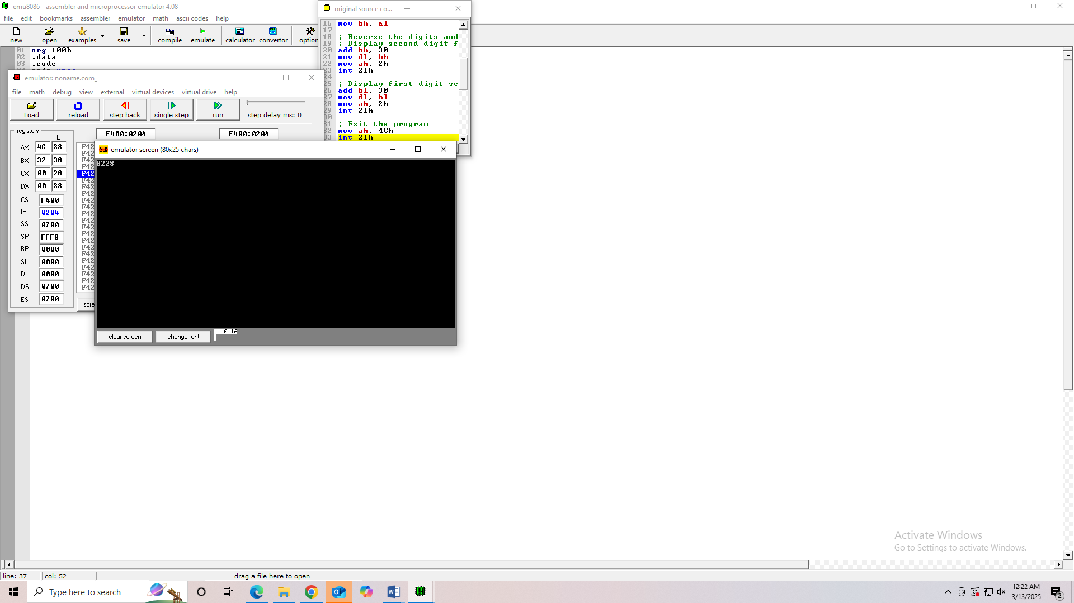

**TASK NO: 02**

org 100h

.data

.code

main proc

mov ah, 1h

int 21h

add al, '0'

mov dl, al

mov ah, 2h

int 21h

; Exit the program

mov ah, 4Ch

int 21h

main endp

end main

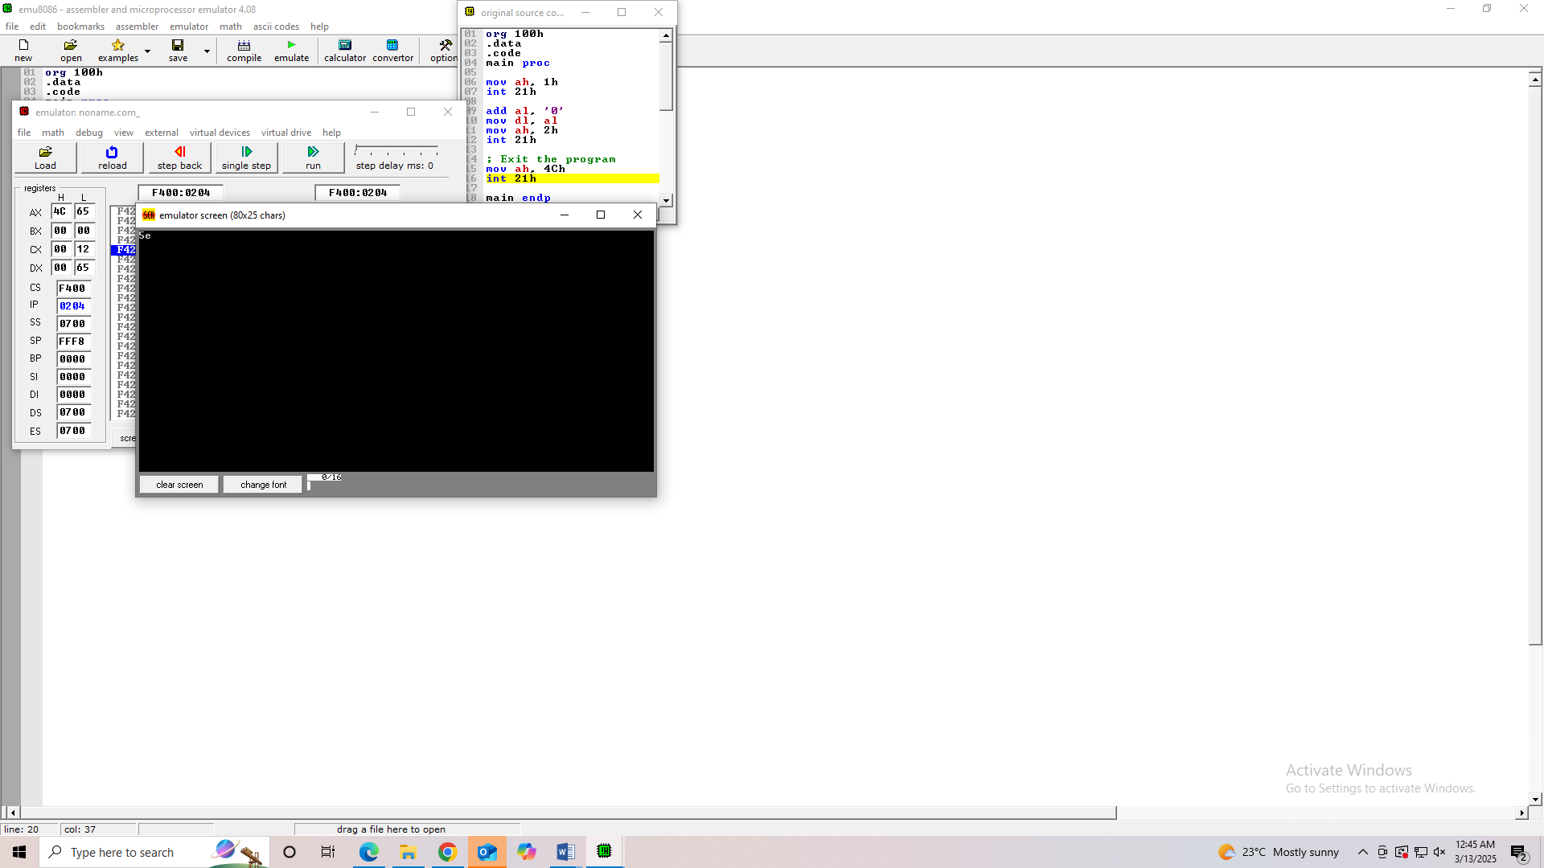

**Task no 3:**

org 100h

.data

.code

main proc

mov bl, 3

mov bh, 5

add bl, bh

mov dl, 6

sub bl, dl

t

add bl, 30h

mov dl, bl

mov ah, 2h

int 21h

; End program

mov ah, 4Ch

int 21h

main endp

end main

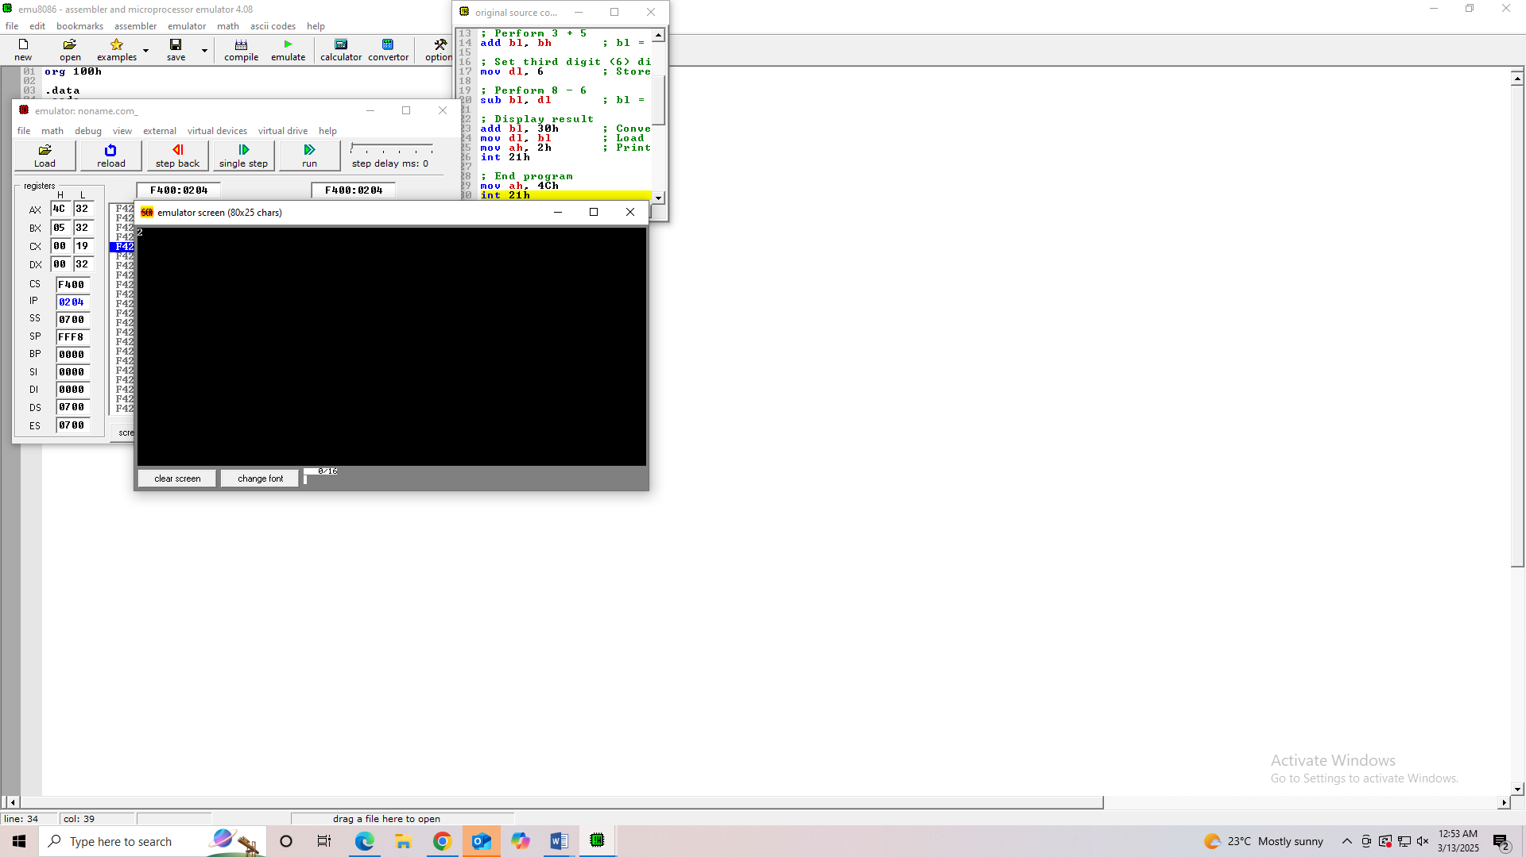

**Task no : 04**

org 100h

.data

.code

main proc

mov ah, 1h

int 21h

sub al, 30h

mov bl, al

mov ah, 1h

int 21h

sub al, 30h

mov bh, al

xchg bl, bh

add bl, 30h ; Convert result back to ASCII

mov dl, bl ; Load swapped first digit into dl

mov ah, 2h ; Function to print character

int 21h

add bh, 30h ; Convert result back to ASCII

mov dl, bh ; Load swapped second digit into dl

mov ah, 2h ; Function to print character

int 21h

; End the program

mov ah, 4Ch

int 21h

main endp

end main

